**Floating Action Button**

Se utiliza en el Scaffold

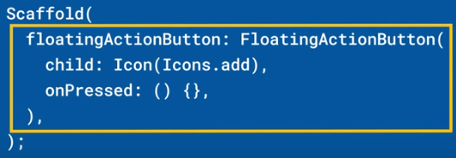 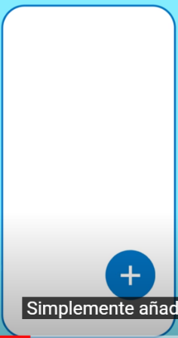

Se puede “incrustar” en un BottomNavigationBar

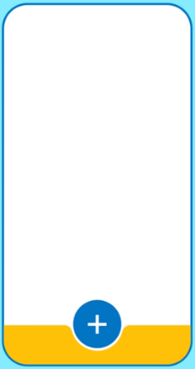 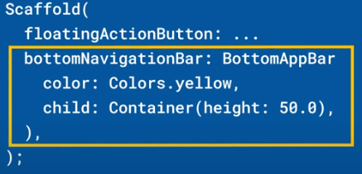 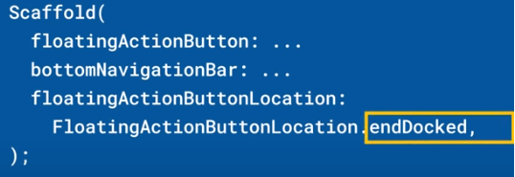

|  |  |
| --- | --- |
| **Código** | **Comentarios** |
| import 'package:flutter/material.dart';  class FloatingActionButtonScreen extends StatelessWidget {    const FloatingActionButtonScreen({Key? key}) : super(key: key);    @override    Widget build(BuildContext context) {      return Scaffold(        appBar: AppBar(          title: const Text('FloatingActionButton'),          centerTitle: true,        ),        body: const Center(          child: Text('Ejemplo de FAB en un bottomNavigationBar'),        ),        floatingActionButton: FloatingActionButton(          child: const Icon(Icons.add),          splashColor: Colors.purple,          hoverColor: Colors.orange,          onPressed: () {},        ),        bottomNavigationBar: BottomAppBar(            color: Colors.cyan,            shape: const CircularNotchedRectangle(),            child: Container(              height: 50,            )),        floatingActionButtonLocation: FloatingActionButtonLocation.centerDocked,      );    }  } |  |

Se ve así:



                                                                                                       